**Greedy Algorithm**

hum current state ko dekhty howay decision lety hain

**Hashing in data structure**

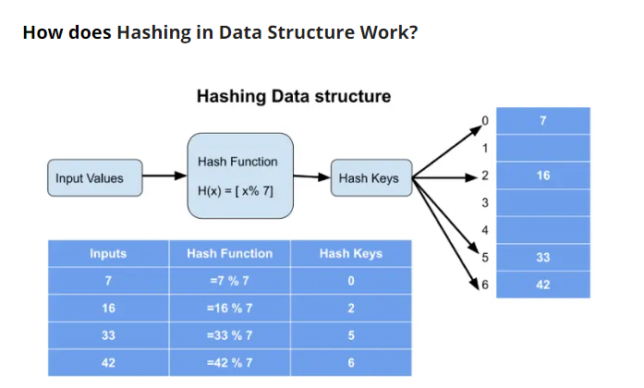https://www.knowledgehut.com/blog/programming/hashing-in-data-structure